**Steps of Submitting the Information about Opening Report on GMS System**

the procedure is as follows:

1. click Xw

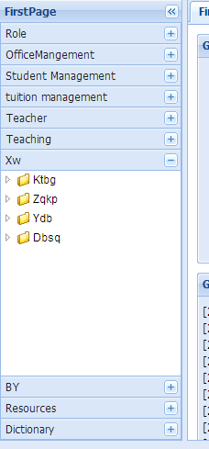

1. click Ktbg

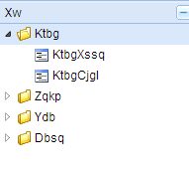

1. click KtbgXssq

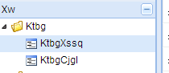

1. click add and then write information about your own opening report

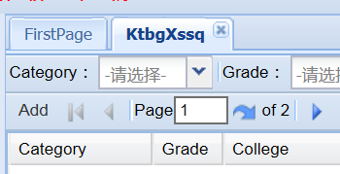

1. Please ask your own supervisor to audit your opening report application on GMS system, finished!